JMP instructions for a split plot analysis,

Really, the only new thing this week is the combination of two old things: specifying random effects (week 3) and specifying factorial treatment structures (weeks 6 and 7). The computer handles all the ugly details. I illustrate this using the PA study.

These data are simulated based on characteristics of a real study. That's to ensure privacy. The results described in lecture were based on one simulate data set. Unfortunately, I inadvertently overwrote that. So, the results here do not match those in the lecture notes. My profuse apologies for the potential confusion.

Reminder about the study design:

Schools grouped into blocks, each with 2 similar schools. Treatments randomly assigned to schools within block: either intervention or control. PA measured on kids within schools. Second "treatment" factor is gender: boy or girl.

There are two data sets: pa2.xlsx has the balanced subset. This has 5 boys and 5 girls in each school. pa.csv has the full data set. Unequal numbers of boys and girls in each school.

Load the data. I had issues with school, which JMP wanted to read as numeric. Since Active and Control aren’t numbers, they appeared in my preview window as missing values (a big dot). Clicking Restore Default Settings fixed the problem.

To fit this model, add all model terms to the construct model effects box. You need to include the main plot error (block*school for this study).

Make sure that all factor variables are nominal (e.g. block needs to changed).

Make block*school a random effect.

Highlight it in the Construct Model Effects box, then click the red triangle by Attributes

And select Random

The Fit model dialog should look like this:

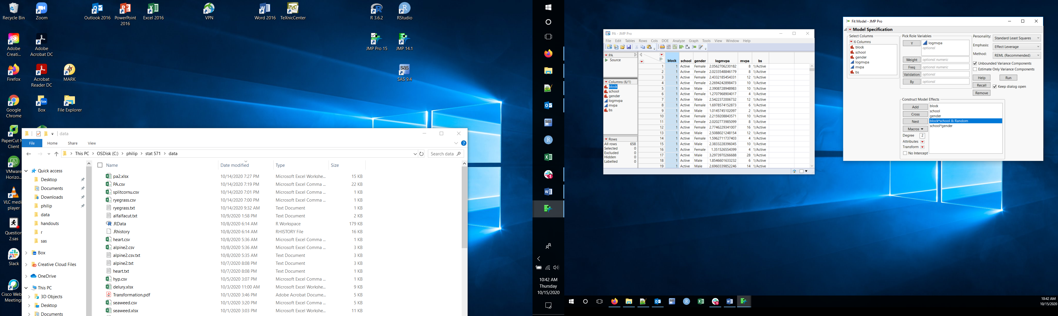

There are multiple methods to estimate variance components. By default, JMP will use REML, as shown in the Method box at top right of the dialog. Also, by default JMP will allow negative estimates of variance components. This is a good thing. When you click Run, you get the output you have come to expect. All the “after the ANOVA” activities are done using each box of lsmeans.

If you want to see expected mean squares, change method to EMS (traditional) and run the fit. The EMS information is near the bottom of the first column of results, below the box of parameter estimates. It is presented in a compact way:

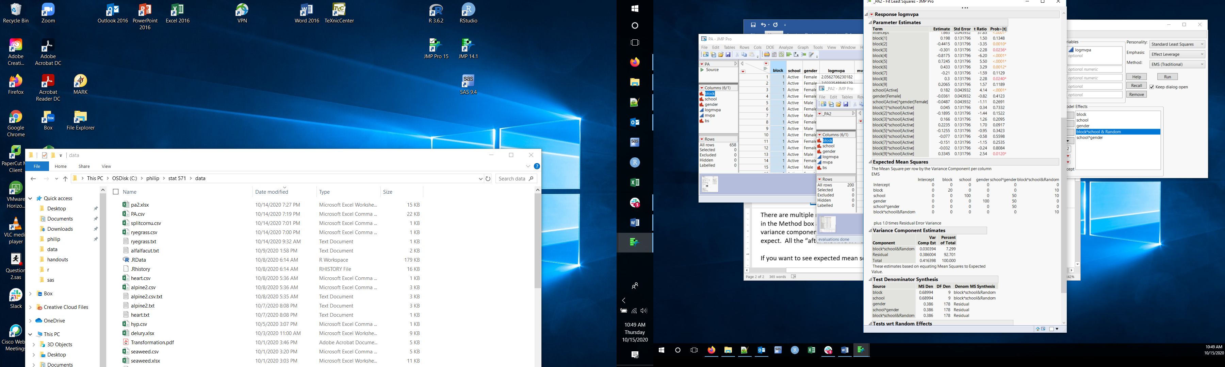

Each line in the EMS table tells you the E MS for that effect. The numbers in that row are the coefficients for the effect in each column. The note at the bottom tells you that 1*Var(error) is omitted from each line.

Starting with block*school, the last row, you see that:

the EMS for block*school is 10*Var(block*school) + Var(error)

the EMS for school is 100*Q(school) + 10*Var(block*school) + Var(error)

where I use Var() to indicate the variance component for a random effect and Q() to indicate the quadratic function of fixed effects.

If you look closely, you see that the F test denominator for school is block*school and the F test denominator for gender and school*gender is the residual. When the appropriate denominator is a linear combination of E MS, you get a block of output labeled Test Denominator Synthesis that gives you the details.

What if the main plot design is a CRD? You still need to indicate the main plot error. This requires a variable that indicates each school. I’ll demonstrate using the PA data, i.e. ignoring blocks. Bs is the variable that uniquely identifies each school. Unfortunately, JMP has to be told about the relationship between bs and the other main plot variables. In a CRD, the main plot error (bs) is nested in the main plot treatment (school). **You must indicate this nesting, otherwise JMP does strange things.** Add bs to the model effects box, then highlight bs in the box and school in the variables list and click Nest. Then make bs(school) random. The Fit model dialog should look like:

